**An outline of steps taken to prepare the data.**

SQL is used to pull the data

* Query for extracting city level data

**SELECT * FROM city_data WHERE city IN ('Allahabad','Delhi') AND country = 'India';**

* Query for extracting global data

**SELECT * FROM global_data;**

Sample 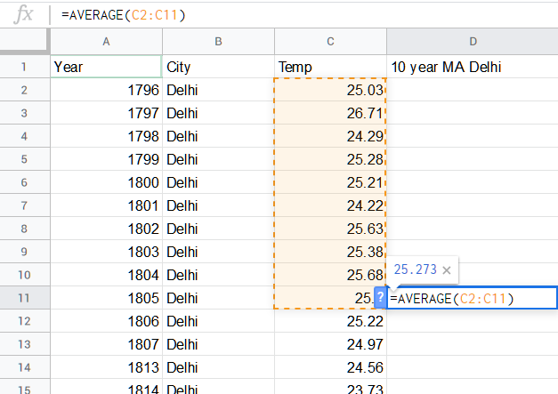of Initial raw data for Delhi (with 10 year Moving average)

Sample of Final raw data (with 10 year Moving Average )

* 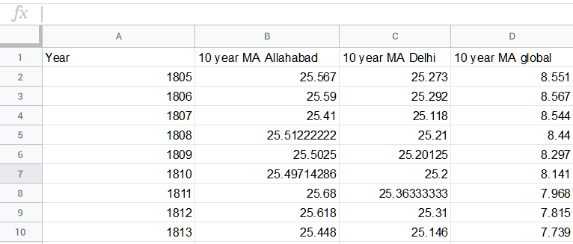10 year Moving Average is calculated for every category (cities: Allahabad, Delhi and Global).

**How did you calculate the moving average ?**

The 10 year Moving Average is calculated using google sheets inbuilt function called **AVERAGE()**, which is used to calculate average of first 10 years(1796 - 1805) and then the next 10 years(1797-1806) and so on.

**Key Consideration when deciding how to visualize the trends**

The average temperature of both cities and global is categorized as three categories (Allahabad, Delhi and Global).

It is assumed that the temperature given is measured on Celsius scale.

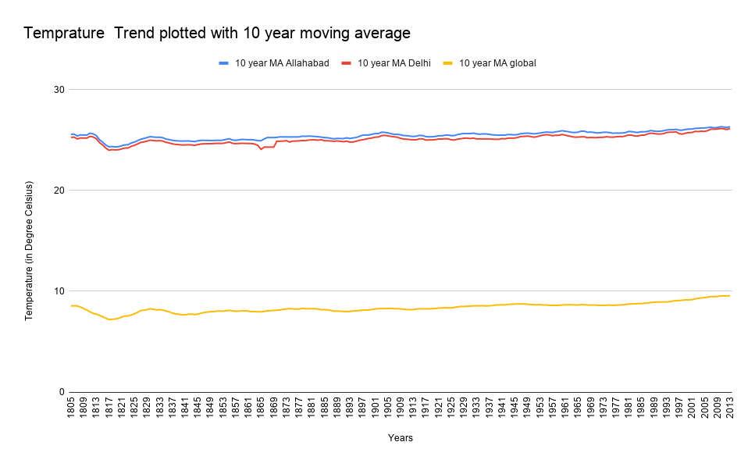A 10 year moving average is taken for all three categories , making a trend/line chart w.r.t Year vs Avg. temperature.

After the calculation of moving averages, a line chart is plotted

**Line chart with local and global temperatures:**

**Observations:**

1. The global temperature is very low as compared to temperature trend of Allahabad and Delhi.
2. We can see a dip in every line plotted at around year 1818.
3. The temperatures for the three columns have increased gradually over the course of 200 years.
4. The correlation of coefficient for (Delhi vs Global is 0.9225) and for (Allahabad vs Global is 0.9409.), Indicating that both Delhi and Allahabad have a very strong relationship with Global temperature trend.
5. From year 1805 to 2005

Rise in temperature for Allahabad is **0.639**.

Rise in temperature for Delhi is **0.588**.

Rise in temperature for Global is **0.827**.